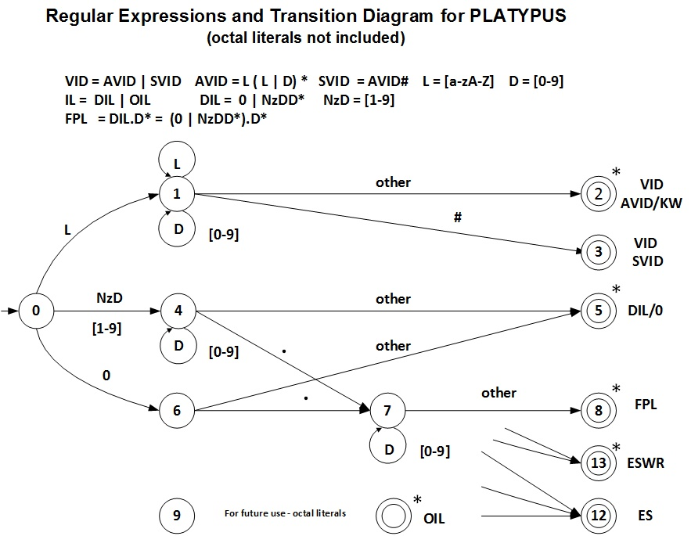

Transition Table
Current  State | INPUT SYMBOL |  |  |  |  |  | State Type  (Not Accepting or Accepting State)
Current  State | [a-zA-z] | 0 | [1-9] | . | # | other | State Type  (Not Accepting or Accepting State)
0 | 1 | 6 | 4 | IS/ES | IS/ES | IS/ES | NOAS
1 | 1 | 1 | 1 | ES/AS2 | 3 | 2 | NOAS
2 | IS | IS | IS | IS | IS | IS | VID AVID/KW - ASWR
3 | IS | IS | IS | IS | IS | IS | VID SVID - ASNR
4 | ES/AS5 | 4 | 4 | 7 | 5 | 5 | NOAS
5 | IS | IS | IS | IS | IS | IS | DIL - ASWR
6 | ES |  |  | 7 | ES | 5 | NOAS
7 | ES/AS8 | 7 | 7 | ES/AS8 | 8 | 8 | NOAS
8 | IS | IS | IS | IS | IS | IS | FPL - ASWR
9 |  |  |  |  |  |  | NOAS
10
11
12 | IS | IS | IS | IS | IS | IS | ES - ASNR
13 | IS | IS | IS | IS | IS | IS | ESWR - ASWR

IS – Illegal State ES – Error State ES/AS – Error State or Accepting State
NOAS – Not Accepting State
ASWR - Accepting State With Retract ASNR - Accepting State No Retract

